Final Exam Project
1) Enter your name, student ID, platform and date
Name: Jay Gupta
Class: CIS054 C/C++ Programming
Platform (Mac or PC): PC
Date: 5/14/2020

2) PROJECT DESCRIPTION
Create an application that searches a file of male and female first names. A link to the file is provided on the class webpage. "FirstNames.txt" is a list of the most popular baby names in the United States and was provided by the Social Security Administration.
Each line in the file contains a boy's name and a girl's name. The file is space-delimited, meaning that the space character is used to separate the boy name from the girl name. The file begins with:
Noah Emma
Liam Olivia
Mason Sophia
Jacob Ava
William Isabella
Ethan Mia
James Abigail
Write a program that asks the user to enter a name. The program then searches the file for the name and displays the position of the name in the file if it matches either a boy name or a girl name. The program also displays a message if the name could not be found. Sample outputs:
Enter a name to search: Daniel
Daniel is ranked 12 for boy names
Daniel was not found for girls

Enter a name to search: Cassandra
Cassandra is ranked 511 for girl names
Cassandra was not found for boys

Enter a name to search: Taylor
Taylor is ranked 76 for girl names
Taylor is ranked 462 for boy names

NOTE: You can use any method you wish to match the name input on the keyboard with the names in the file. You can compare two strings ignoring upper/lower case by using #include<cstring> in C++ or #include<string.h> in C and the following comparison if ( stricmp(string1,string2) == 0)
If your compiler does not have stricmp, you may need to use _stricmp or strcasecmp.
3) DISCUSSION
a) What did you do to develop the program? ("Followed the Directions" is not a complete description)
I looked at the project requirements, and the sample output. Then, I thought of how I would go about implementing the solution. I thought to do binary search, but then I didn’t know how I was going to display the rank, and knew that sequential search would be much faster, cleaner code, and much more intuitive.
I looked at my previous code, and when I ran into a problem, one of which I will describe below, I looked up the error message online and tried to fix it.

b) What problems did you have and how did you overcome the problems?

A major problem I had was with stricmp. Apparently, using two string variables was not acceptable, at least in my case. I had to convert the variable declarations to char arrays, and only then did the function work. I checked online, and the documentation were using string literals, which I knew wouldn’t work in my case. It was a minor tweak, and I think that char arrays are a lot more useful, as they have many use cases.
I didn’t have many other problems, since I referred to my old code on how to open and work with files. That time, I did have a few problems with opening the file; however, this was fixed by looking at documentation.

4) PROGRAM OUTPUT
Submit seven screen shots:
1) search result for your first name
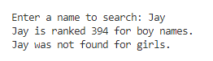
2) search result for a name used for both boys and girls, such as Taylor, Ryan or Dylan
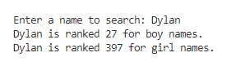
3) search result for a name used only for boys
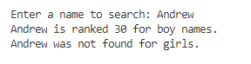
4) search result for a name used only for girls
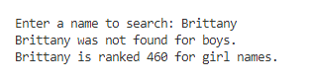
5) search result for a name that at the first record in the file
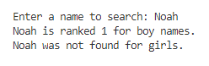
6) search result for a name that is at the last record in the file
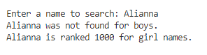
7) search result for a name that is not in the file
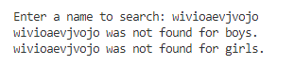

5) PROGRAM LISTING
Copy and paste YOUR code.
/**
* Jay Gupta
* Program: FirstNames.cpp (V1.0)
* Date: 5/14/2020
*/

#include <iostream>
#include <string>
#include <cstring>
#include <fstream>
using namespace std;

int main() {
// declare variables
char searchString[80];
char currentBoy[80], currentGirl[80];
int currentPosition = 0;

int positionOfBoy = 0;
int positionOfGirl = 0;

char fileName[] = "C:\\Users\\jaygu\\School\\SJCC\\C++\\Assignments\\Module 14\\14.4 - Final\\FirstNames.txt";

ifstream mainFile (fileName);

if (!mainFile) {
cerr << "Unable to open " << fileName << endl;
return 1;
}

// request a search string
cout << endl << "Enter a name to search: ";
cin.getline(searchString, 80);

while (!mainFile.eof()) { // while not at end of file:
mainFile >> currentBoy;
mainFile >> currentGirl;

currentPosition++; // update position for next iteration

if (stricmp(searchString, currentBoy) == 0) {
positionOfBoy = currentPosition;
}
if (stricmp(searchString, currentGirl) == 0) {
positionOfGirl = currentPosition;
}
}

// Results!
if (positionOfBoy != 0) {
// if 0, never found
cout << searchString << " is ranked " << positionOfBoy << " for boy names." << endl;
} else {
// is 0, not found for boy names
cout << searchString << " was not found for boys." << endl;
}
if (positionOfGirl != 0) {
cout << searchString << " is ranked " << positionOfGirl << " for girl names." << endl;
} else {
cout << searchString << " was not found for girls." << endl;
}

cout << endl;

return 0;
}

